Calorie goal test

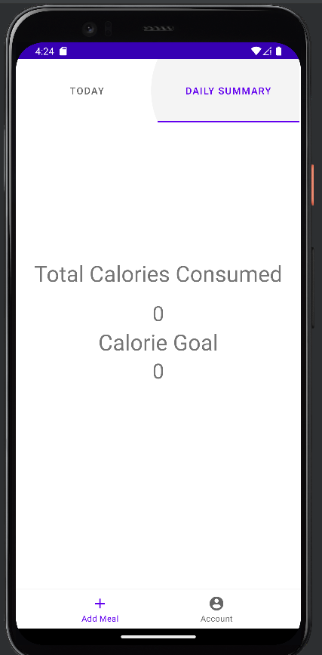
- Fill out edit account form and return to summary page

Initially zero

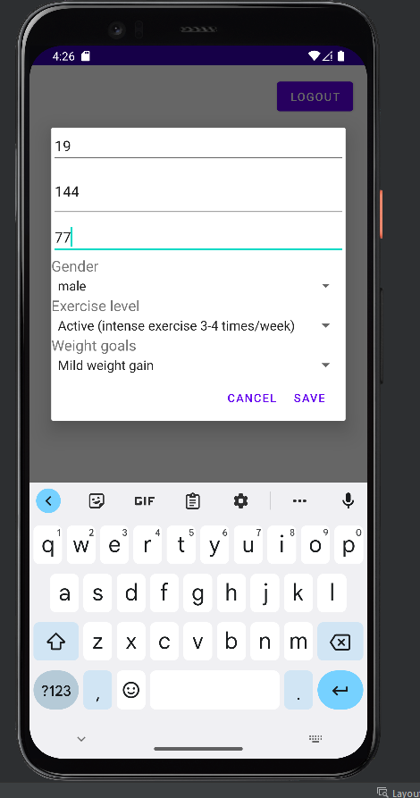

Set up form
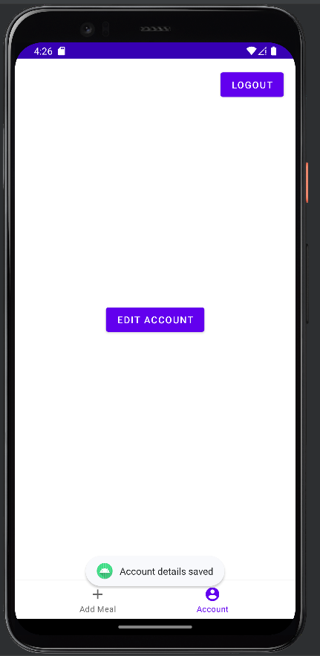

Form submitted

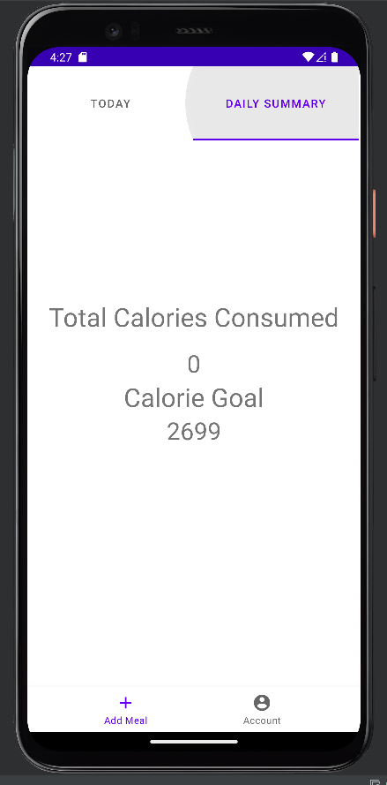

CALORIE GOAL POPULATED TEST PASSED

